

HOLY GRAIL OF

ALGORITHMS



I DEDICATE THIS BOOK TO ALL THE OGs THAT DIED FIGHTING FOR A BETTER GRADE.

Contents

TIME COMPLEXITY OF SORTING ALGORITHMS 5

TIME COMPLEXITY OF ALGORITHMS 6

How to determine time complexity 6

Code examples 7

TREES 11

BINARY TREE 11

AVL TREE 12

MIN HEAP 13

**Insertion** 13

**removal** 13

MAX HEAP 13

**Insertion** 13

**removal** 13

RED BLACK TREES 15

HUFFMAN TREE 15

ROTATIONS 16

MATH PROPERTIES CHEAT SHEET 20

LOGARITHMIC PROPERTIES CHEAT SHEET 21

Algorithm theory (about complexity) 22

MASTER THEOREM 23

HASH TABLES 24

ALGORITHM TYPES (THEORY + CODE EXAMPLES) 26

Brute Force Algorithms: 30

Greedy Algorithms: 30

Divide and Conquer Algorithms: 30

Dynamic Programming Algorithms: 30

Randomized Algorithms: 30

Backtracking Algorithms: 31

TREE TRAVERSALS (in order, post order, for binary trees) 32

BIG Oh of DATA structures in different operations (search, insert, remove) 33

DATA STRUCTURES (THEORY) 37

EXAMS 38

ADS TEST EXAM 23 38

Theory (true/false) 38

Whether n is power of 2 39

Divide and conquer. 39

Red black tree / worst case number of rotations when inserting in red black tree 40

Min heap 40

41

Djikstra / topological sort 41

THEORY (true false / sorts) 41

Kruskal / mst – minimum spanning tree 42

# TIME COMPLEXITY OF SORTING ALGORITHMS

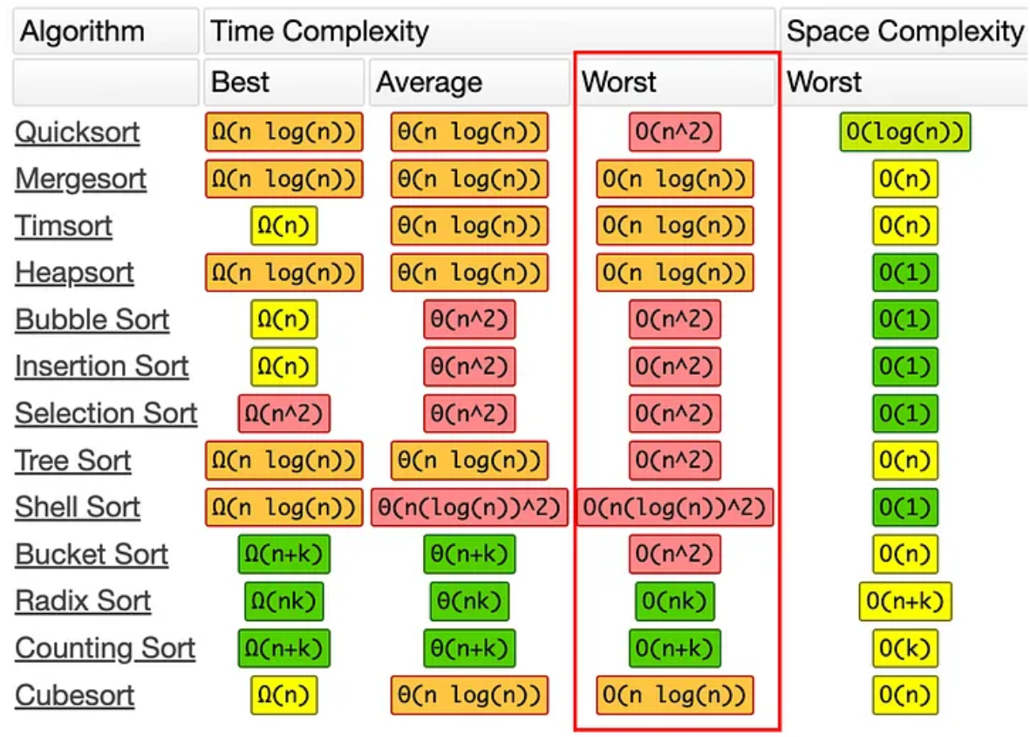

# A picture containing text, screenshot, font Description automatically generatedTIME COMPLEXITY OF ALGORITHMS

## How to determine time complexity

**O(n^2) - Quadratic Time Complexity:**

Look for nested loops where the number of iterations depends on the input size.

**O(n log n) - Linearithmic Time Complexity:**

**divide the input** into smaller parts and **recursively** solve them, resulting in a logarithmic factor.

**O(log n) - Logarithmic Time Complexity:**

* Look for algorithms that repeatedly divide the input in half, such as binary search on a sorted list.
* The runtime decreases drastically with each division, leading to logarithmic time complexity.

## Code examples

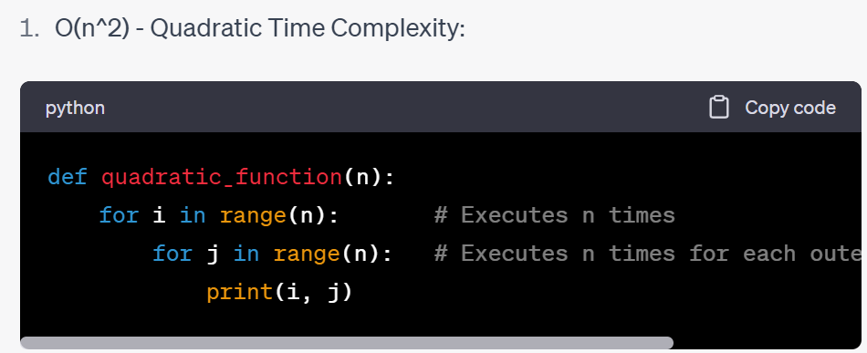

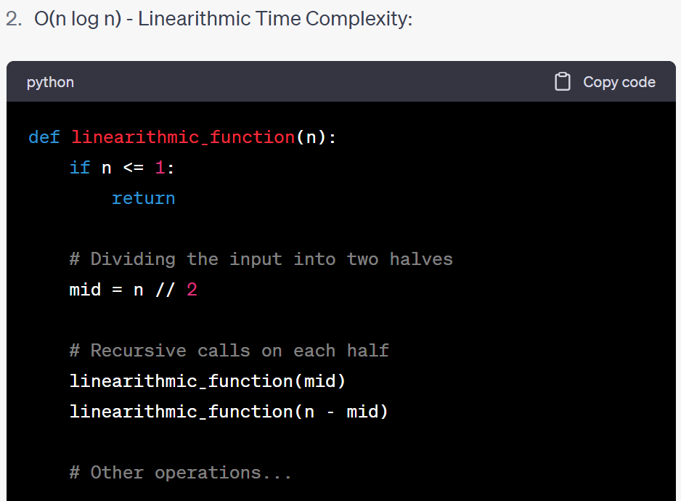

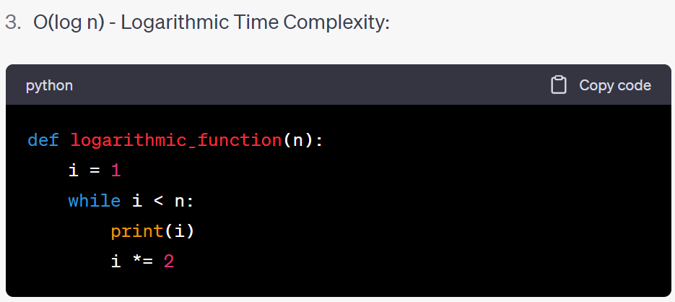

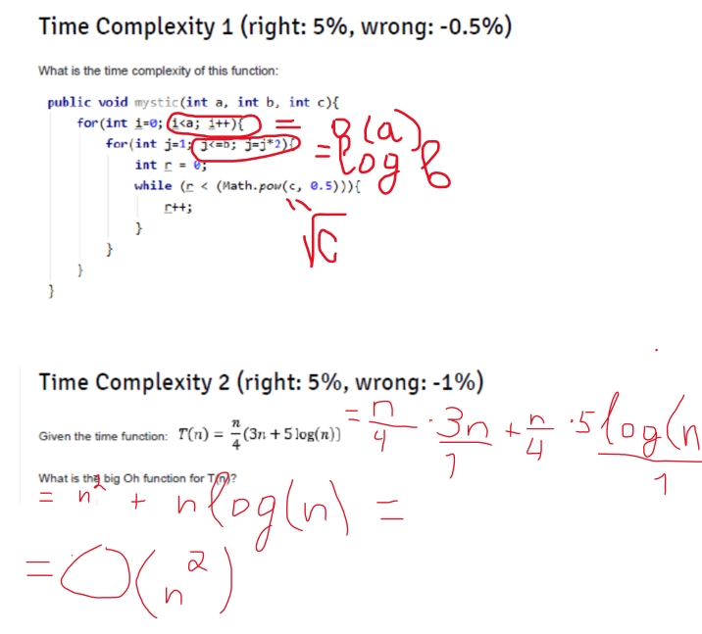



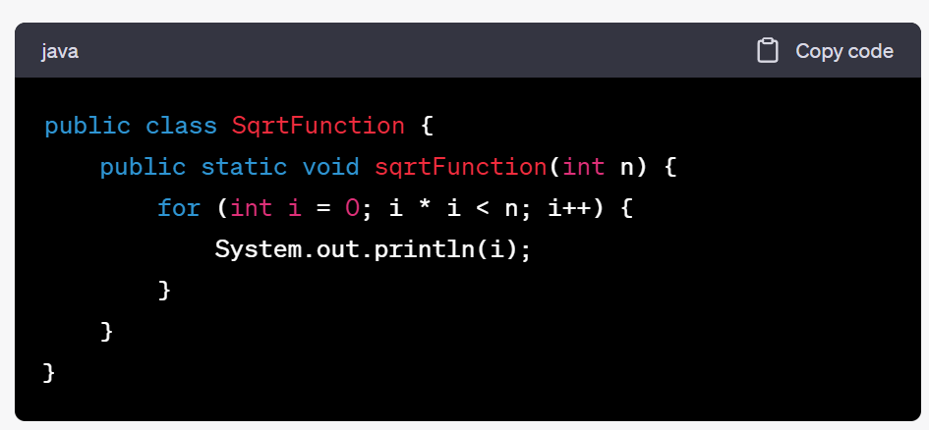

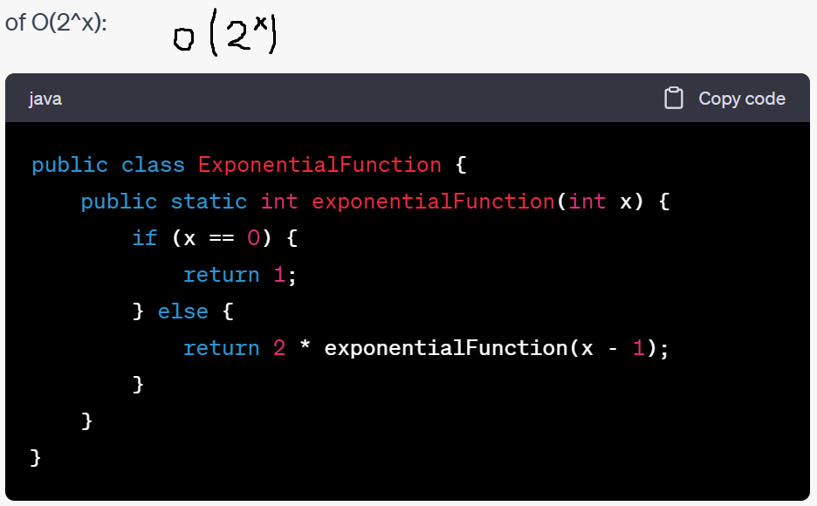

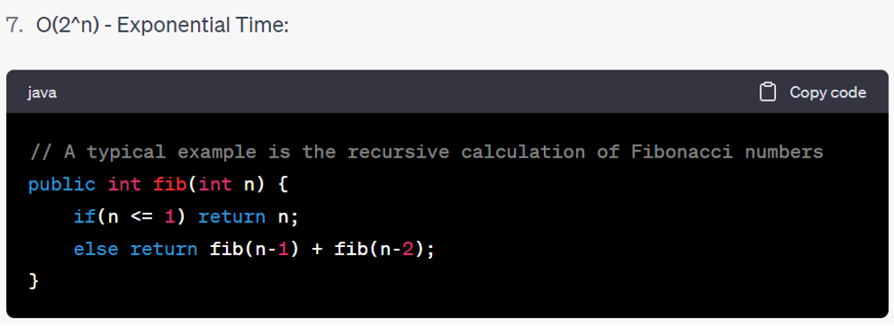

# TREES

## BINARY TREE

**Insertion:**

NUM > ROOT | INSERT TO RIGHT

NUM < ROOT | INSERT TO LEFT

* Balance does not matter

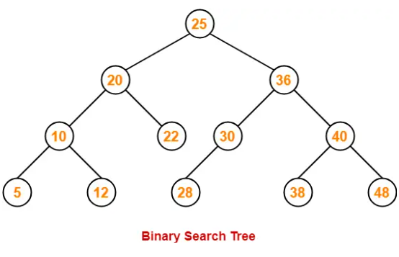

## AVL TREE

**Insertion:**

NUM > ROOT | INSERT TO RIGHT

NUM < ROOT | INSERT TO LEFT

**BALANCE DOES MATTER!**

**Balance factor = LEFT child height – RIGHT child height**

**BALANCE FACTOR != 2 OR -2**

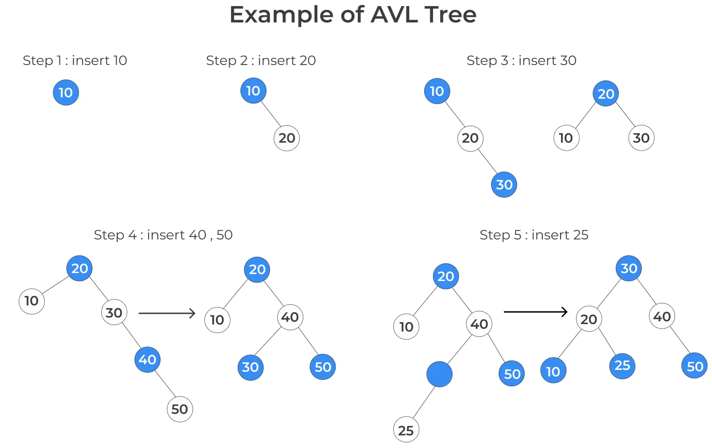

## MIN HEAP

**Insertion**

1. Insert at the last available position.
2. Compare data we just inserted to parent’s data. If it is LESS than the parent’s data – swap. Continue to do this until we reach root node.

**removal**

1. Swap the last element of a tree with ROOT/MIN.
2. Delete the last/MIN element.
3. Down heap (resolve) – Always look out which children are LOWER and swap with lower one until it is resolved.

## MAX HEAP

**Insertion**

1. Insert at the last available position.
2. Compare data we just inserted to parent’s data. If it is MORE than the parent’s data – swap. Continue to do this until we reach root node.

**removal**

1. Swap the last element of a tree with ROOT/MAX.
2. Delete the last/MAX element.
3. Down heap (resolve) – Always look out which children are HIGHER and swap with higher one until it is resolved.

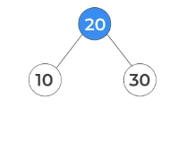

**LAST AVAILABLE POSITION** IN THE PICTURE ABOVE IS:

**LEFT CHILD OF NODE 10**

**LAST ELEMENT** IN THE PICTURE ABOVE IS **30**

## RED BLACK TREES

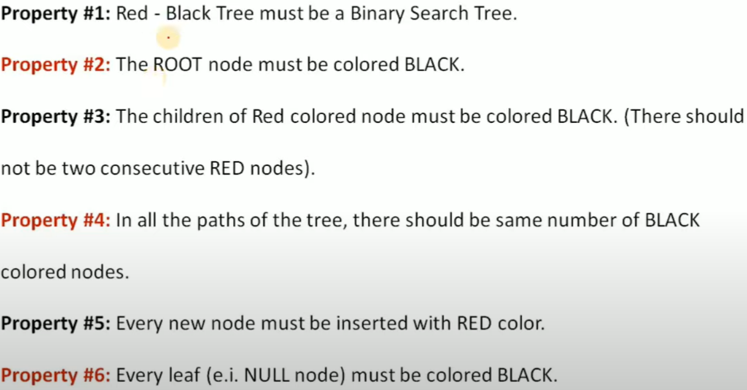

## HUFFMAN TREE

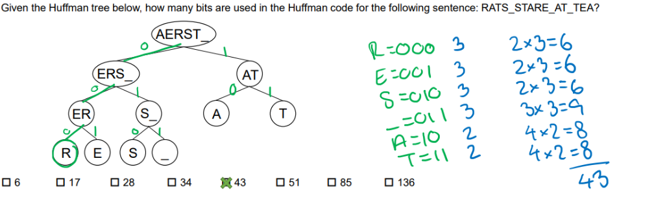

Write 0 and 1 to each node, 0 – left node, 1 – right node.

Then write off path to the letter in bits, as ex.: R = 000. (3 bits in total)

Count how many times each char occurs in the sentence and multiply that number by total number of bits for that specific char.

**ROTATIONS

**LL CASE:**

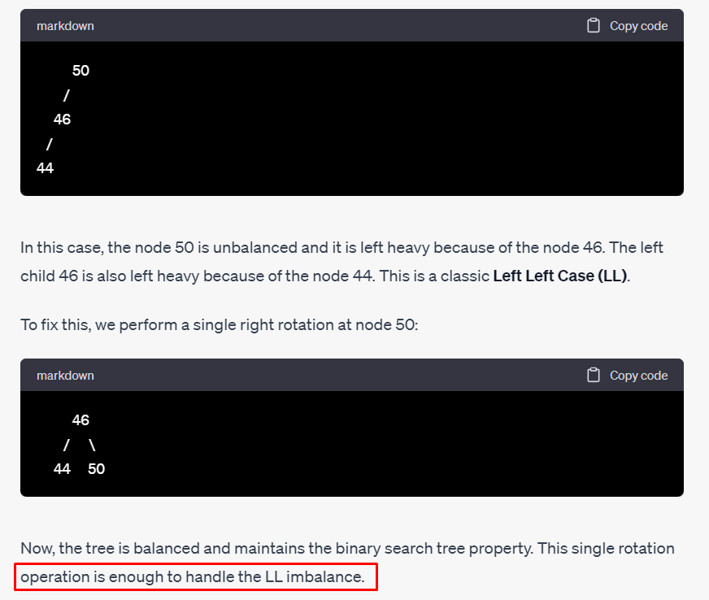

**RR CASE:**

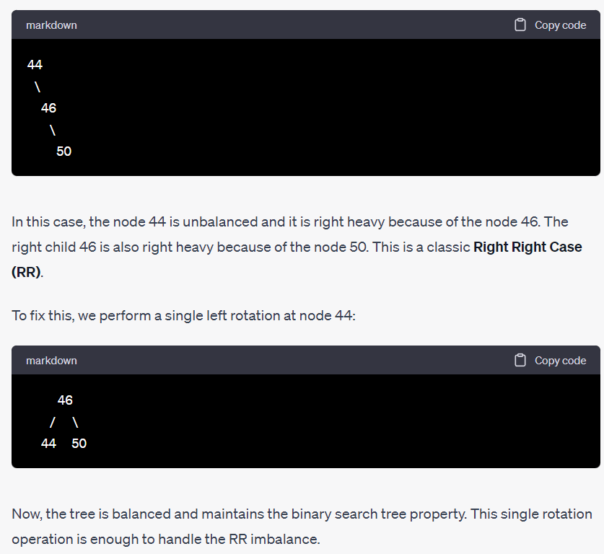

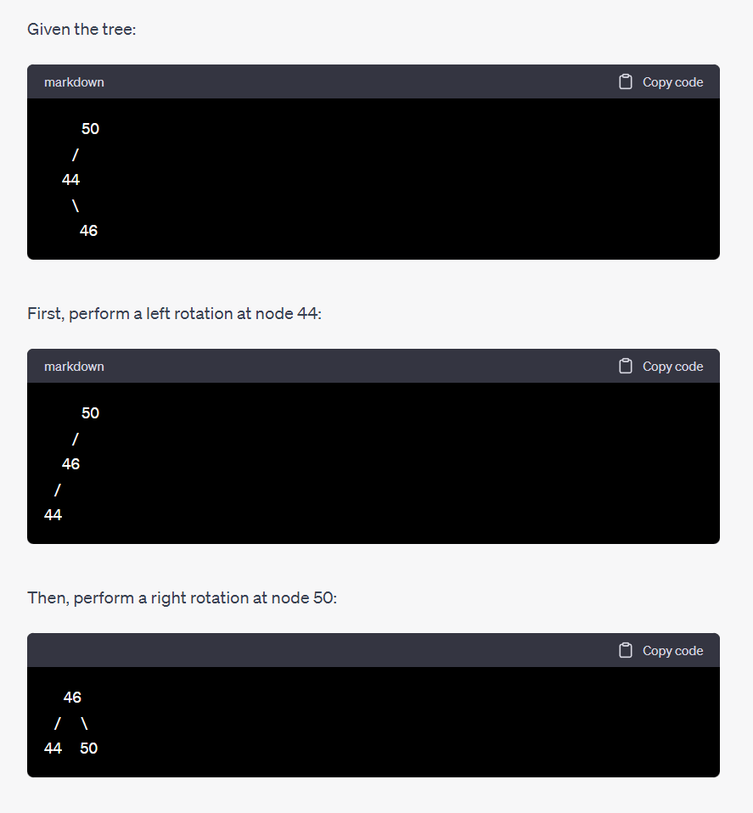**LR CASE:**

**RL CASE:**

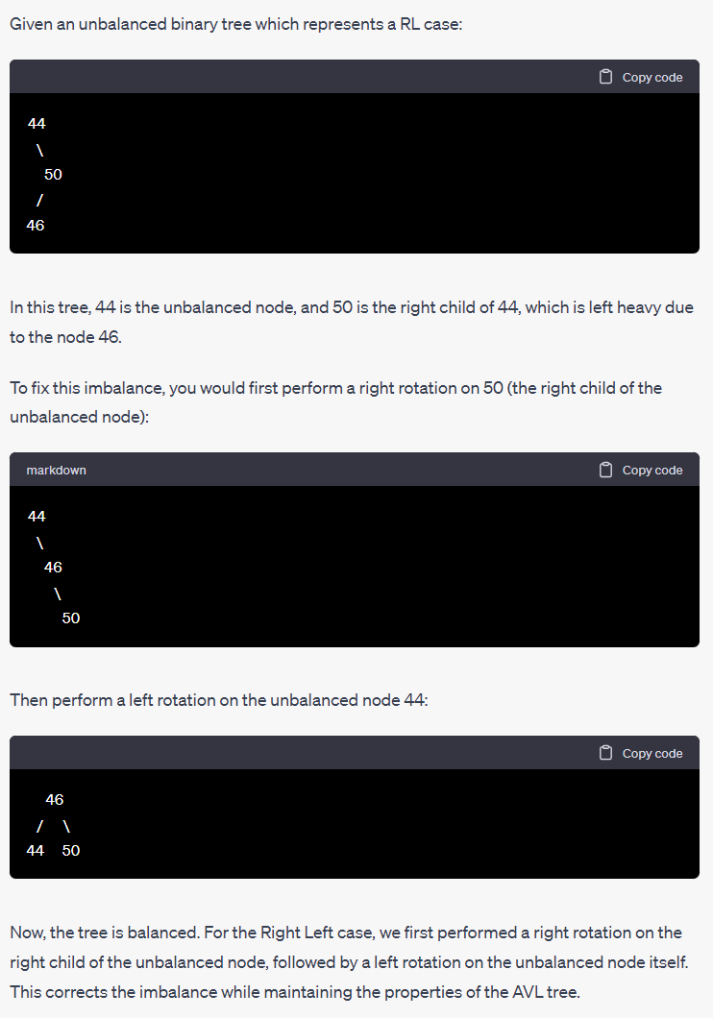

# MATH PROPERTIES CHEAT SHEET

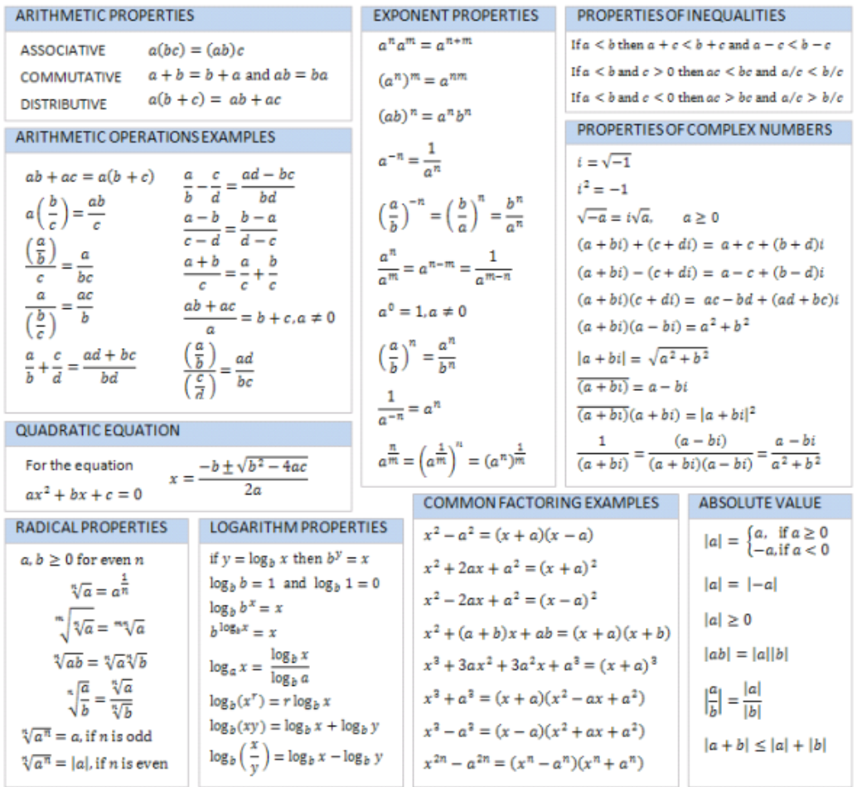

# LOGARITHMIC PROPERTIES CHEAT SHEET

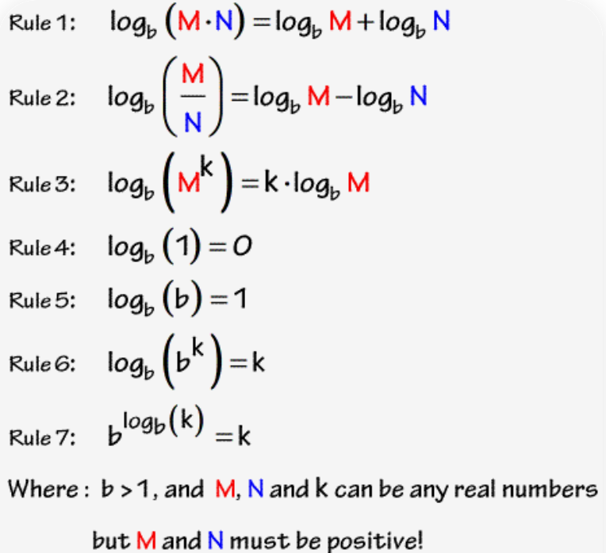

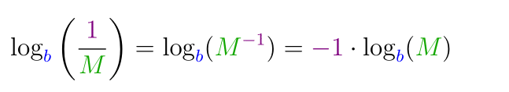

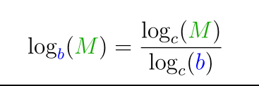

# Algorithm theory (about complexity)

**O(1) - Constant Time**: An algorithm is said to have a constant time when it is not dependent on the input data size (n). No matter the size of the input data, the running time will always be the same.

**O(n) - Linear Time**: An algorithm is said to run in linear time if its time complexity increases in direct proportion to the input size. For example, for a loop that goes through an array of n elements once, the time complexity is O(n).

**O(log(n)) - Logarithmic Time**: This time complexity is often seen in divide-and-conquer type algorithms, like binary search. These algorithms halve/double the relevant data in each step, reducing the data they operate on quickly.

**O(n log(n)) - Linear Logarithmic Time**: This is seen in algorithms that divide the problem into smaller pieces and process each piece in linear time. Sorting algorithms like quicksort and mergesort are examples of algorithms with this time complexity.

**O(n^2) - Quadratic Time:** Algorithms with quadratic time complexity have a running time that's a quadratic function of the input size. Examples include simple algorithms like bubble sort, selection sort, or insertion sort, and algorithms that have a loop within a loop that each iterate n times.

**O(n^3) - Cubic Time:** Algorithms with cubic time complexity have a running time that's a cubic function of the input size. This is often seen with algorithms that involve three nested loops working on the input data.

**O(2^n)** - Exponential Time: Algorithms with exponential time complexity are often recursive algorithms that solve a problem of size N by recursively solving two smaller problems of size N-1. The total number of operations quickly balloons for larger input sizes.

**O(n!)** - Factorial Time: Factorial time complexity occurs for algorithms that solve a problem by generating all permutations of the input data. This is seen in the traveling salesman problem solved by brute-force search, for example.

# MASTER THEOREM

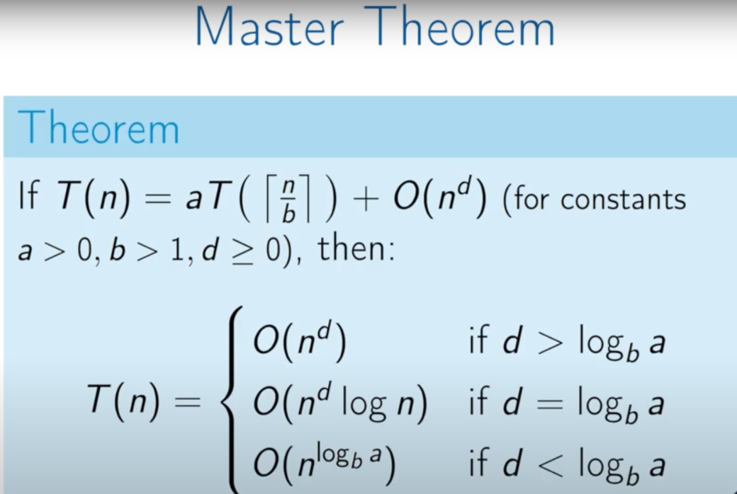

# HASH TABLES

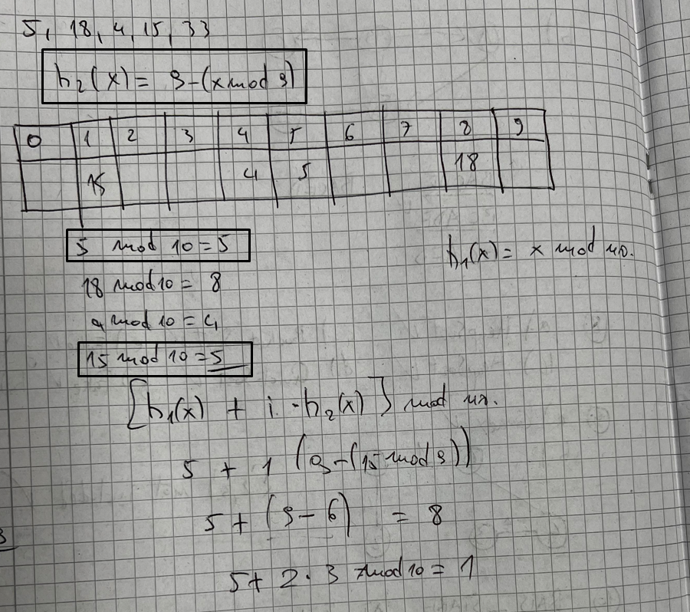

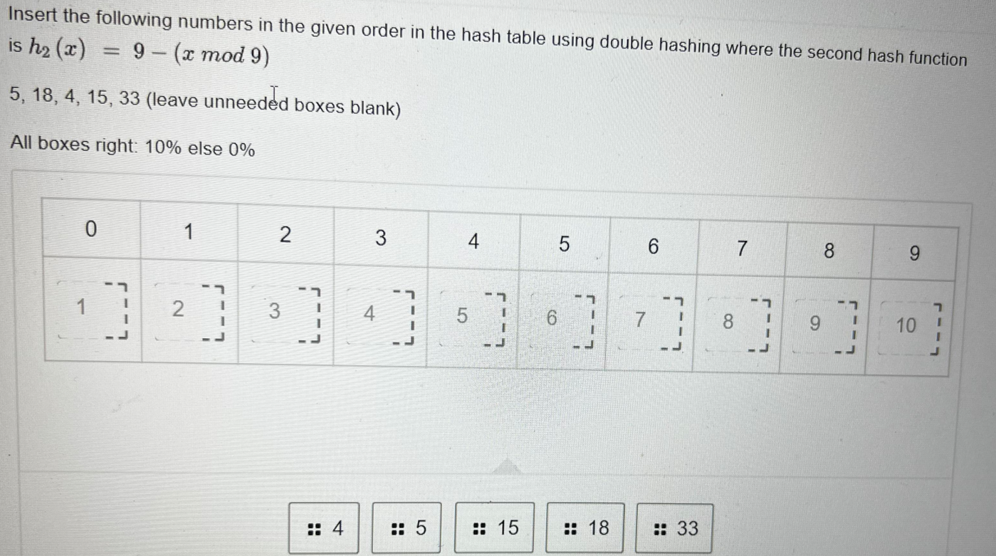

If it is not quadratic hashing then in case of collision, insert it to the next available slot. As example: if you get slot 5 and there is already a number in slot 5, you insert it in slot 6 (if 6 is free)

# ALGORITHM TYPES (THEORY + CODE EXAMPLES)

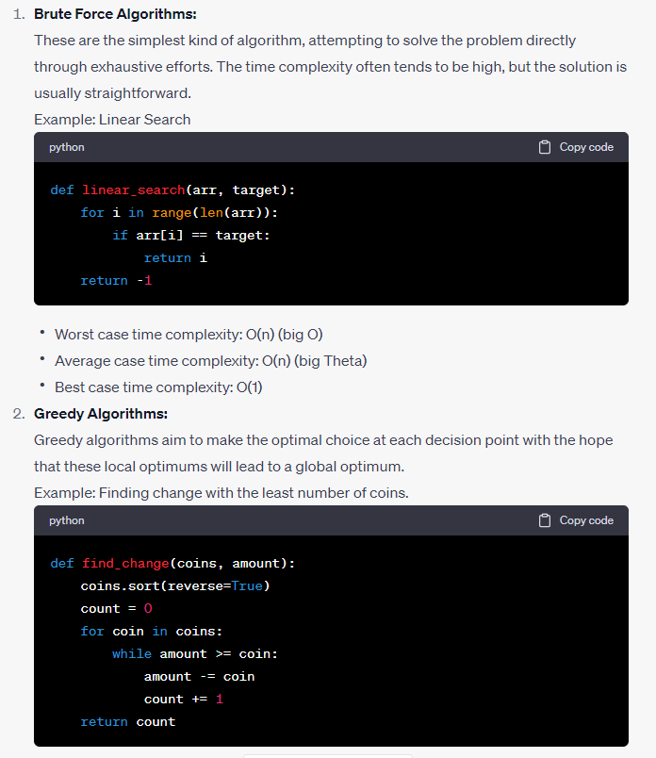

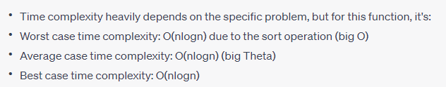

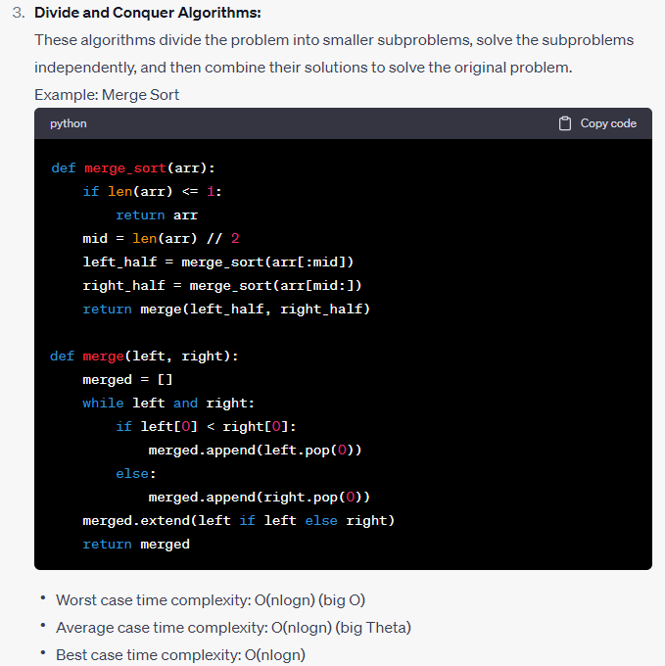

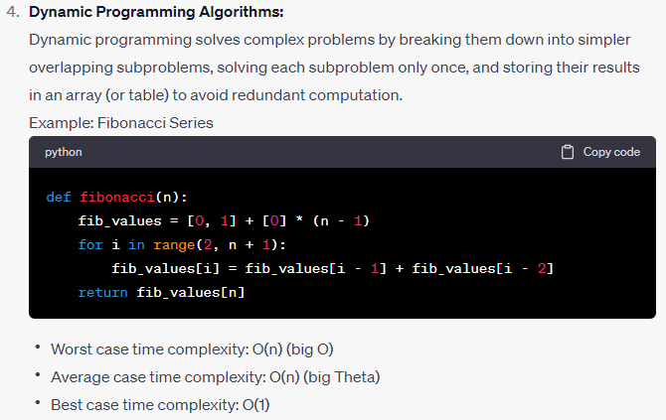

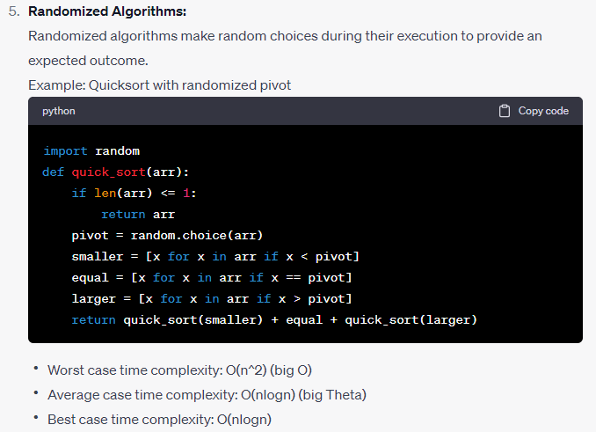

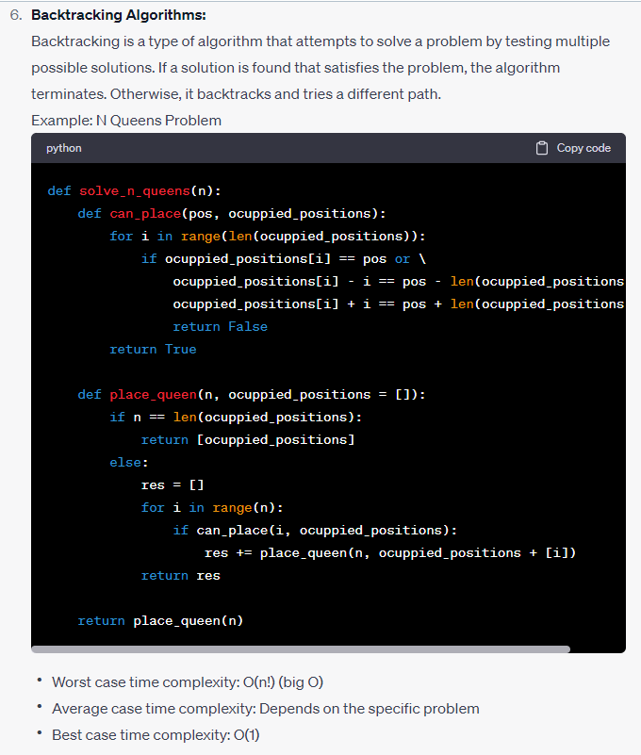

# Brute Force Algorithms:

Brute force algorithms solve problems by enumerating all possible solutions and choosing the best one. They do not need any domain knowledge and are very straightforward to implement. However, they are often inefficient, and infeasible for problems of a large size due to high time complexity.

**Examples:** Bubble Sort, Selection Sort, Generating all subsets of a set, Traveling Salesman Problem (computing all possible routes)

# Greedy Algorithms:

Greedy algorithms make the locally optimal choice at each stage with the hope that these local optima will lead to a global optimum. They are typically efficient and easy to implement, but they do not always yield the best global solution.

**Examples:** Dijkstra's algorithm for the shortest path, Huffman coding (used in file compression), Kruskal's and Prim's algorithms for Minimum Spanning Tree, Activity Selection Problem

# Divide and Conquer Algorithms:

Divide and Conquer algorithms work by recursively breaking down a problem into two or more sub-problems of the same type (divide), until these become simple enough to be solved directly (conquer). The solutions to the sub-problems are then combined to give a solution to the original problem.

**Examples:** Quick Sort, Binary Search, Strassen's Algorithm for matrix multiplication, Fast Fourier Transform (FFT)

# Dynamic Programming Algorithms:

Dynamic programming is a method for solving complex problems by breaking them down into simpler overlapping subproblems. It is applicable when the subproblems are not independent, and the solutions to the subproblems overlap and reoccur. The key idea is to save the solutions to the subproblems in a table so they can be reused (rather than recomputed), thereby reducing computation time at the expense of storage space.

**Examples:** Bellman-Ford algorithm for the shortest path, Knapsack Problem, Longest Common Subsequence, Optimal Binary Search Trees

# Randomized Algorithms:

Randomized algorithms use a random number at least once during their computation to make decisions. They are used when the solution to the problem is not deterministic or when a deterministic solution is too complex to develop. The goal is not to find the optimal solution but rather an approximate solution close to the optimal one, given that the problem's nature doesn't allow for a deterministic optimal solution in a reasonable time.

**Examples:** Randomized Quick Sort, Randomized Prim's algorithm, Rabin-Karp for string matching, Monte Carlo methods for numerical integration

# Backtracking Algorithms:

Backtracking is a type of algorithm that solves problems recursively by trying to build a solution incrementally. If the partial solution cannot be extended to a valid solution, it backtracks to test another path. It is used when the problem requires trying all possibilities until an acceptable solution is found.

**Examples:** Knight’s tour problem, solving mazes, Sudoku Solver, Eight Queens Problem, Rat in a Maze

This list isn't exhaustive. Each algorithmic paradigm has been used in a plethora of situations and problems, many of which are quite complex. But these are some of the more common examples.

# TREE TRAVERSALS (in order, post order, for binary trees)

# A piece of paper with writing on it Description automatically generated with medium confidenceBIG Oh of DATA structures in different operations (search, insert, remove)

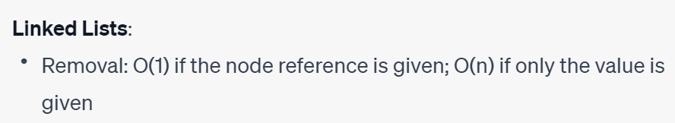

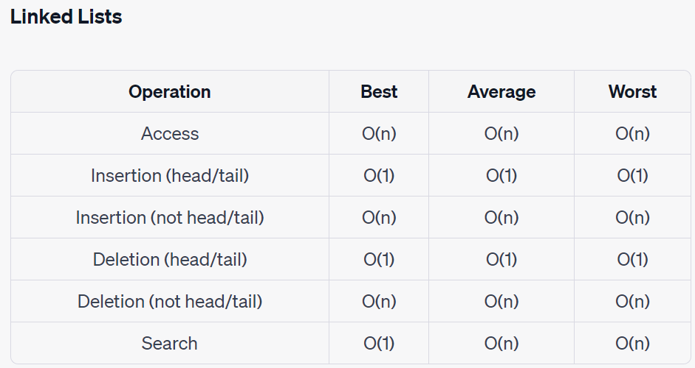

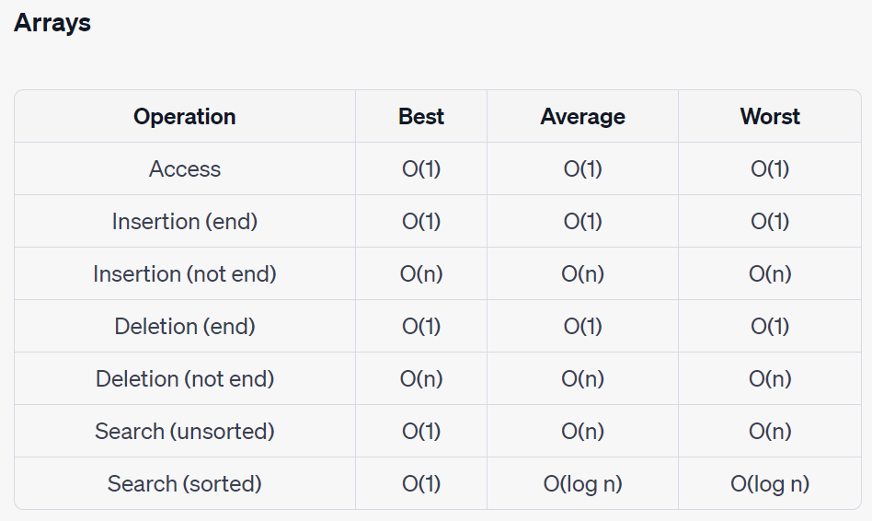

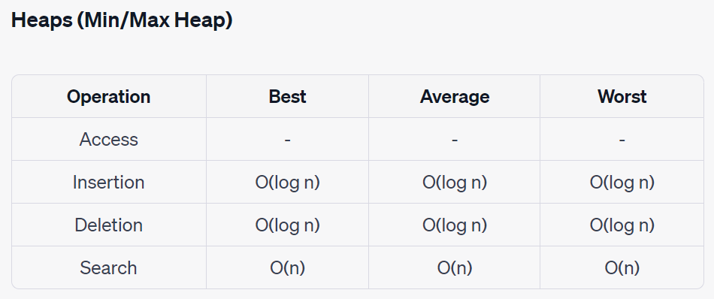

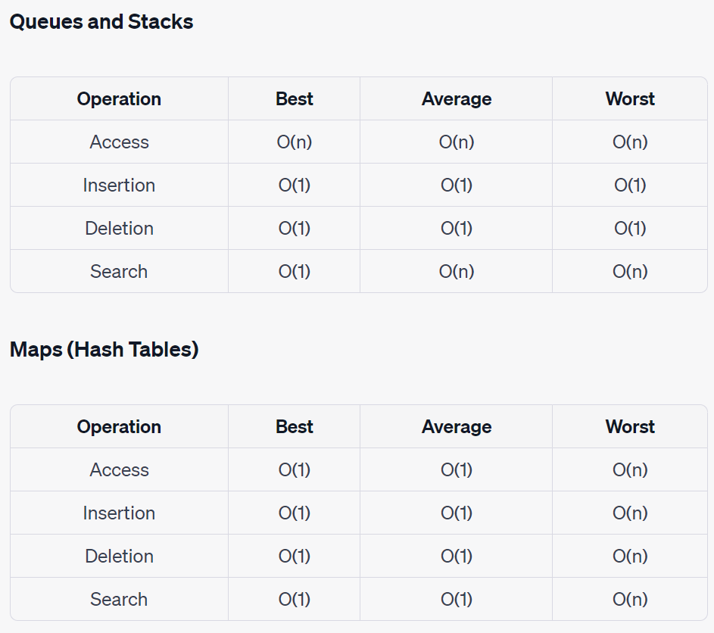

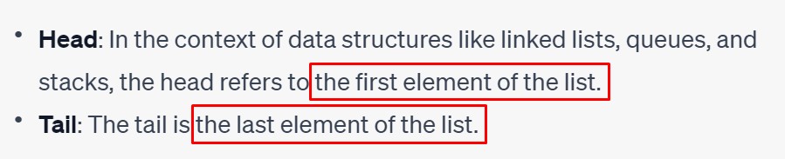

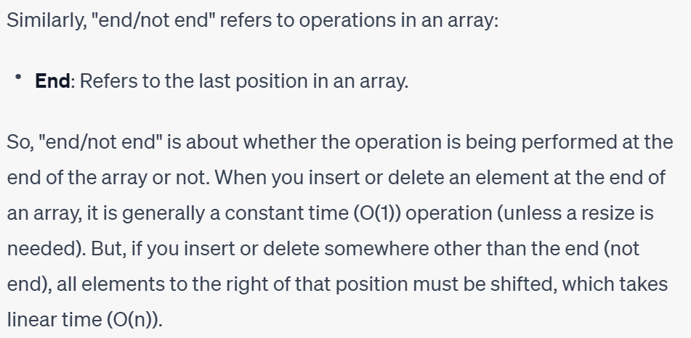

# DATA STRUCTURES (THEORY)

**HEAPS**

A heap is a specialized tree-based data structure that satisfies the heap property: if P is a parent node of C, then the key (the value) of P is either greater than or equal to (in a max heap) or less than or equal to (in a min heap) the key of C. Heaps are commonly used in implementations of priority queues and in algorithms like heapsort.

**ARRAYS**

An array is a basic data structure that contains elements of the same type in contiguous memory locations. Because of this, accessing an array element at a specific index is constant time. However, inserting or deleting an element requires shifting the remaining elements, causing a linear time complexity.

**LINKED LISTS**

A linked list is a linear collection of data elements, whose order is not given by their physical placement in memory. Instead, each element points to the next. Because elements are not indexed, accessing a specific element requires traversal from the head node, resulting in linear time complexity. Insertion and deletion at the head are constant time operations, as they simply require updating a few pointers. If we have a reference to the tail, insertion and deletion at the tail are also constant time operations.

**QUEUES AND STACKS**

Queues and Stacks are dynamic sets of elements that follow specific order principles. A queue follows a First-In-First-Out (FIFO) principle, meaning that the first element added will be the first one to be removed. A stack follows a Last-In-First-Out (LIFO) principle, where the most recently added element is the first one to be removed. Both data structures can insert and remove elements in constant time, but accessing or searching through them requires linear time.

**MAPS**

Maps store elements in key-value pairs and usually use a hash function to efficiently find the value associated with a given key. In a well-dimensioned hash table, the average time complexity for access, insertion, and deletion is constant. However, in the worst-case scenario (where the hash function produces the same index for all keys), the time complexity is linear.

# EXAMS

## ADS TEST EXAM 23

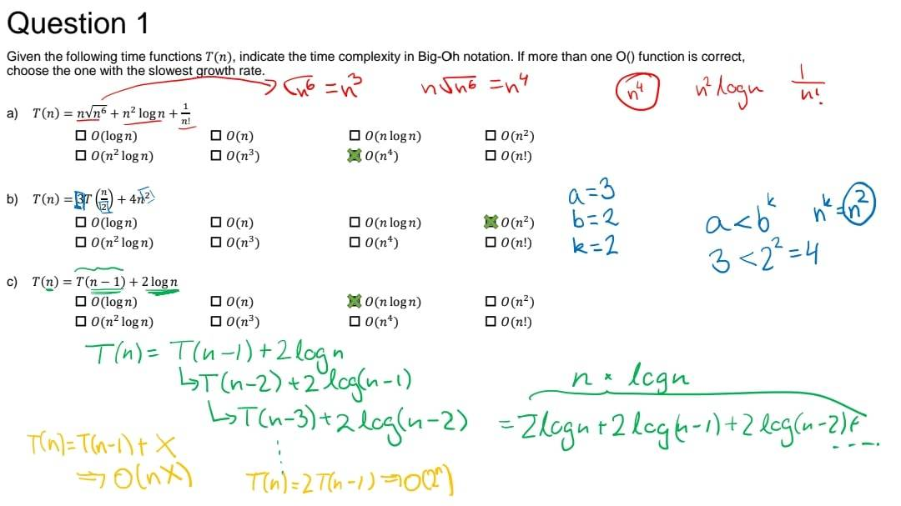

### Theory (true/false)

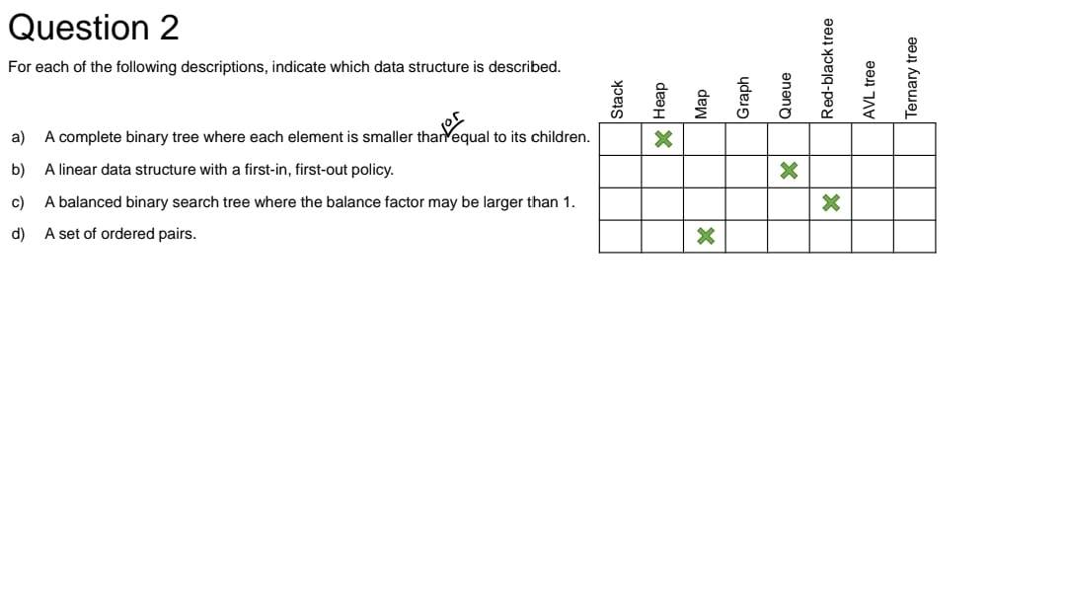

### Whether n is power of 2

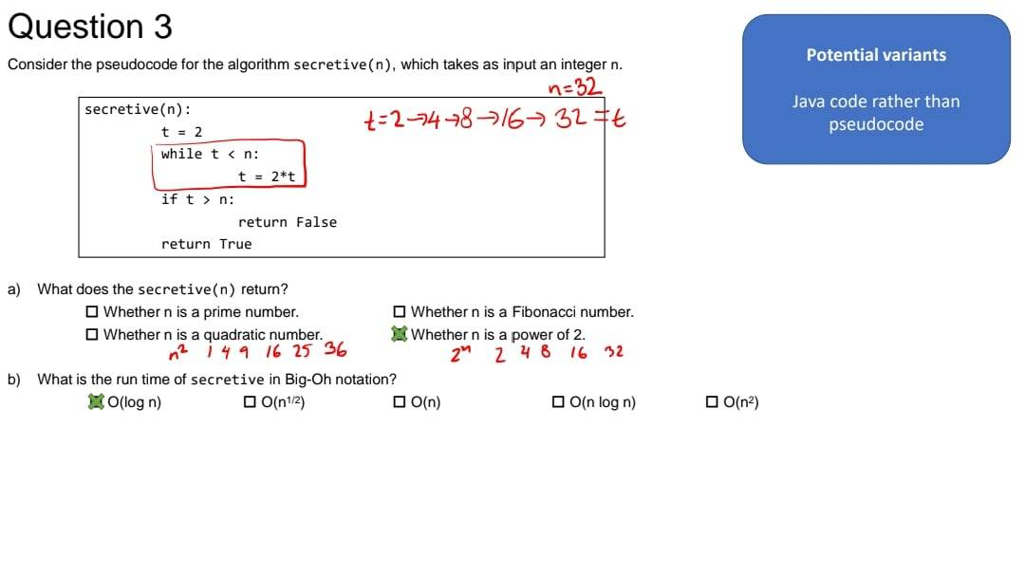

### Divide and conquer.

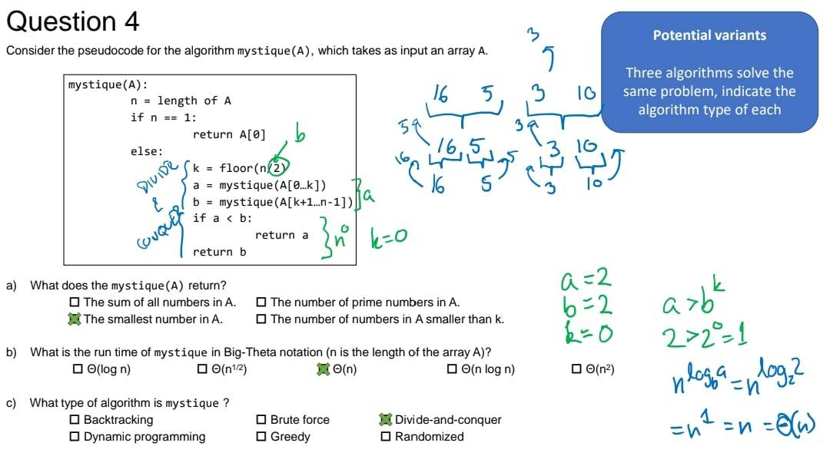

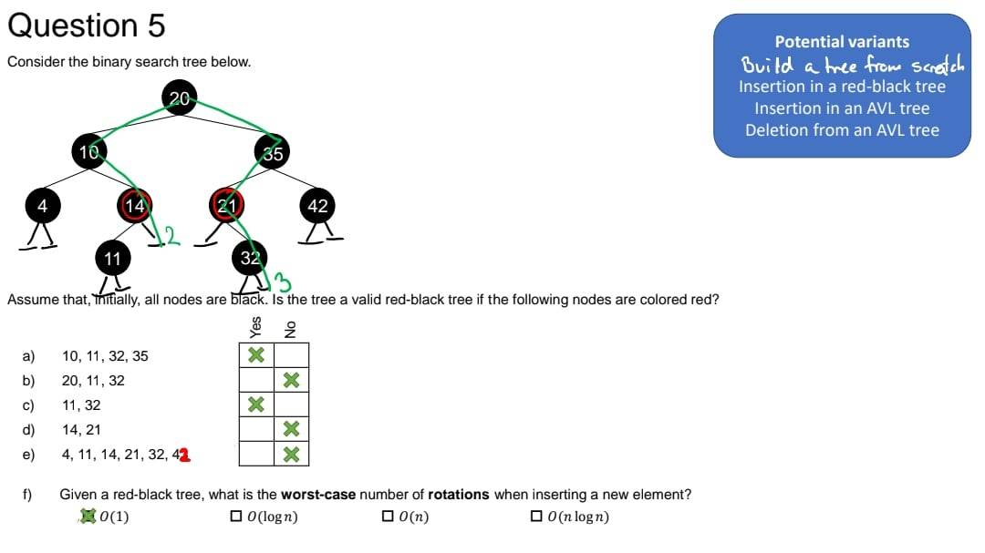

### Red black tree / worst case number of rotations when inserting in red black tree

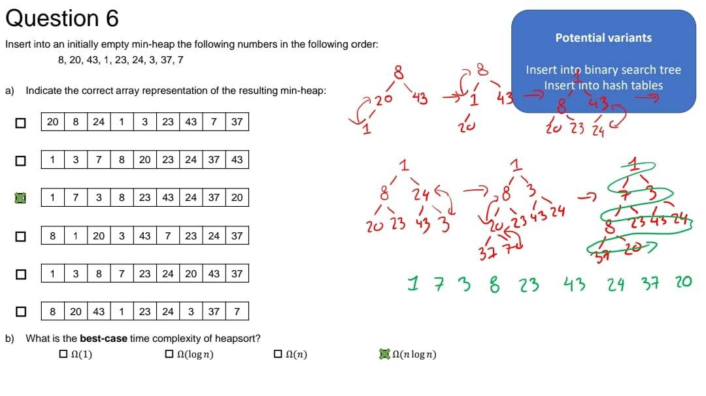

Min heap

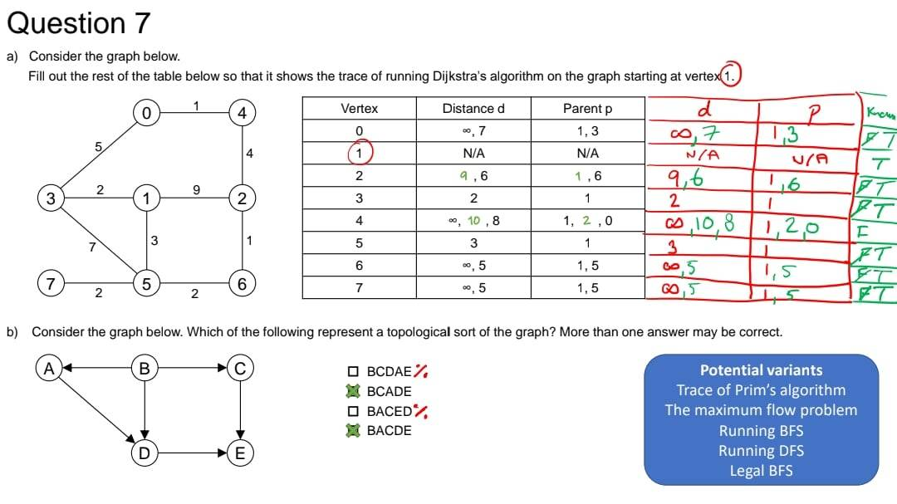

Djikstra / topological sort

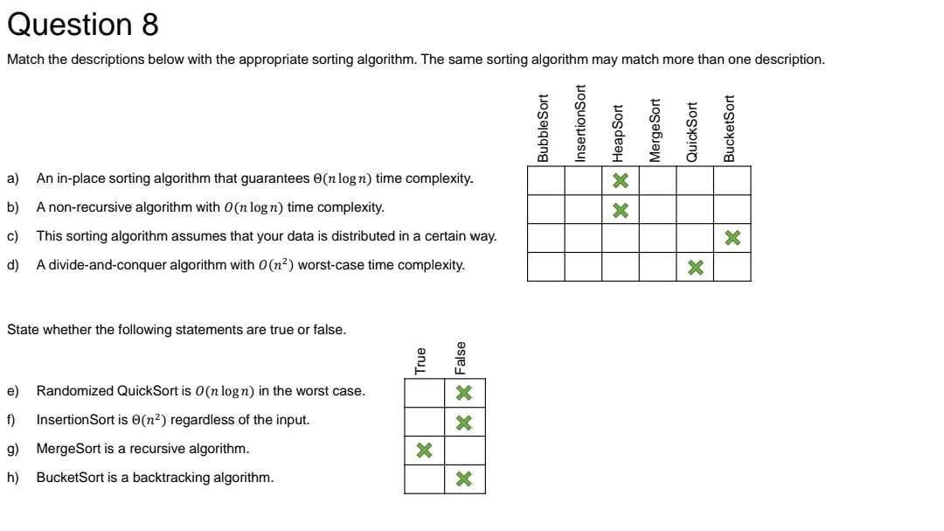

### THEORY (true false / sorts)

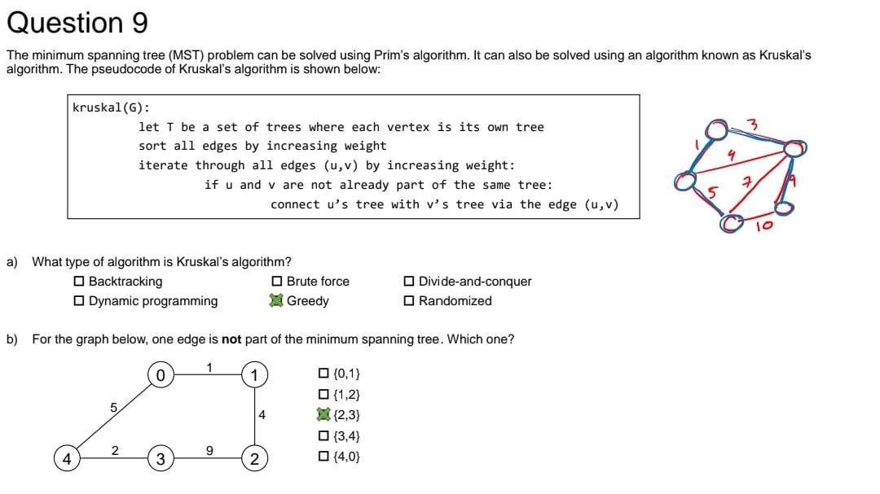

### Kruskal / mst – minimum spanning tree

